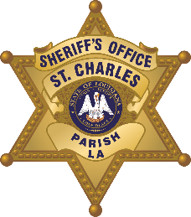

St. Charles Parish Sheriff’s Office
Criminal Investigations Bureau
260 Judge Edward Dufresne Parkway, Luling, LA 70070
Voice (985) 783-1135 • Fax (985) 783-1138
Major Donald Smith - Corporal James Grimaldi
Greg Champagne
Sheriff

N e w s R e l e a s e

D.W.I. ARRESTS
September 28, 2020

Name, Age, Sex: | Address: | Date of Arrest: | Place of Arrest: | Charges:
Washington, Jayquan Lee, 23, Male | 1058 Luling Estates Drive Luling, LA | September 27, 2020 | Interstate 310 | DWI, Possession of Alcohol in Motor Vehicle, Careless Operation
Flowers, Devell Isiah, 20, Male | 192 Beck Street Ama, LA | September 27, 2020 | Paul Fredrick Street Luling, LA | DWI, Reckless Operation, No Seat Belt
Eugene, Akaisha Izelle, 21, Male | 3409 Severn Avenue Metairie, LA | September 25, 2020 | Highway 90 in Luling, LA | Driving on Roadway Laned for Traffic, Tail Lamps Required, DWI, Following too Closely, Possession of Alcohol in Motor Vehicle

