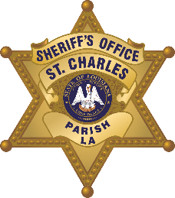

St. Charles Parish Sheriff’s Office
Criminal Investigations Bureau
260 Judge Edward Dufresne Parkway, Luling, LA 70070
Voice (985) 783-1135 • Fax (985) 783-1138
Major Donald Smith - Corporal James Grimaldi
Greg Champagne
Sheriff

N e w s R e l e a s e

D.W.I. ARRESTS
October 5, 2020

Name, Age, Sex: | Address: | Date of Arrest: | Place of Arrest: | Charges:
White, Anthony, Jr., 41, Male | 629 Killona Drive Killona, LA | October 3, 2020 | Canal Street in Luling, LA | DWI, Violation of Stop Sign, Possession of Alcoholic Beverages in Motor Vehicle, Suspended DL, 29th J.D.C. Attachment (2 counts)
Reeves, Cody Allen, 32, Male | 231 David Stozle Road Sugartown LA | October 2, 2020 | Interstate 310 | DWI, Possession of Alcoholic Beverages in Motor Vehicle
Robertson, Ryan Gentry, 33, Male | 216 Bailey Street Boutte, LA | September 29, 2020 | Paul Maillard Road in Boutte, LA | DWI, Reckless Operation with Accident, Headlamps for Vehicle, Expired DL

