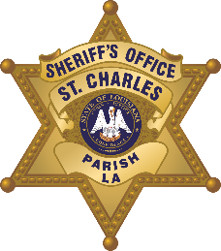

St. Charles Parish Sheriff’s Office
Criminal Investigations Bureau
260 Judge Edward Dufresne Parkway, Luling, LA 70070
Voice (985) 783-1135 • Fax (985) 783-1138
Major Donald Smith - Corporal James Grimaldi
Greg Champagne
Sheriff

N e w s R e l e a s e
James Grimaldi
Public Information Officer
October 6, 2020
Drug Arrest
Anyone with information regarding this incident(s) is asked to call Crime stoppers at 1-877-903-STOP. Citizens do not have to give their name nor testify and could receive up to $2,500.

ARRESTEE: | Scott, Javarion, 22, Male- 104 Mark Twain Drive River Ridge, LA
LOCATION: | Ormond Blvd in Destrehan, LA
DATE: | October 5, 2020
ITEM NO.: | 2004946
CHGS: Possession of a Firearm by Convicted Felon, Possession of Drug Paraphernalia, Possession of Marijuana (2nd Offense), Resisting an Officer, Contributing to the Delinquency of a Juvenile, Illegal Use of a CDS in Presence of Persons Under 17 Years of Age
Sheriff Greg Champagne reports Scott was a passenger of a vehicle that was stopped for a traffic violation. During the stop, Scott was found to be in possession of marijuana, drug paraphernalia, and a handgun. Scott is a convicted felon and cannot possess a firearm. Scott was arrested accordingly.

